**Our Basic Products and Services are:**

* **Educational laboratory equipment, teaching aids, chemicals and models**
* **Analytical, precision, scientific research and quality control lab equipment**
* **Analytical fine chemicals, reagents, culture media and biologicals**
* **Modern agriculture equipment and machineries**
* **Equipment for teaching engineering and vocational training institute**
* **Aluminum doors and widows**

**Educational laboratory equipment, teaching aids, chemicals and models**

**Introduction**

It is imperative for schools to have the latest and high-quality science lab supplies these days. Science is different from any other subject. In order to understand its concepts, one has to look beyond the books and conventional classroom teaching. Effective teaching and learning of science involves seeing, handling, and manipulating real objects and materials. The knowledge that kids attain in classrooms would be ineffectual unless they actually observe the process and understand the relationship between action and reaction.

By virtue of equipping themselves with the latest and the advanced materials and supplies, schools are able to contribute a lot in the scientific advances yet to come. To conclude, schools must have the latest science lab supplies and equipment to make science interesting and effective for students and to encourage them to make significant contributions in the field of physics, biology, chemistry, and other streams of science later in life.

**Physics**

**Measurement**

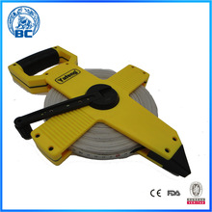 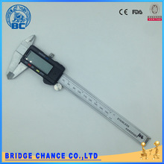 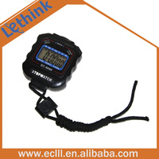

**tape meter vernier caliper three-sow stopwatch**

* **Mechanics**

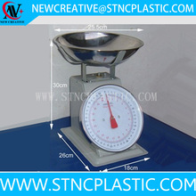 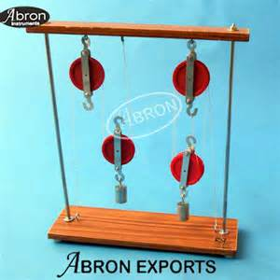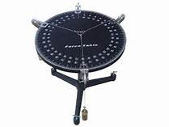

Spring balance/spring **pulley set with stand Force table**

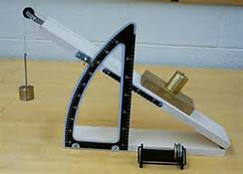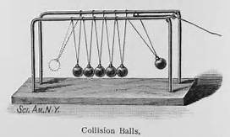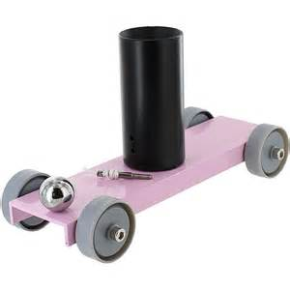

friction on an incline plane collision experiment apparatus ballistic car

* **wave and sound**

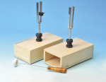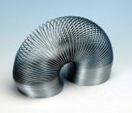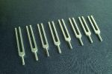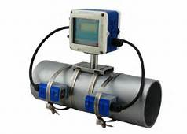

Tuning fork Wave demonstrating spring tuning fork acoustical transmission apparatus

* **Termology**

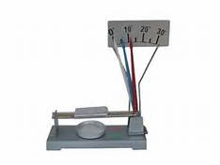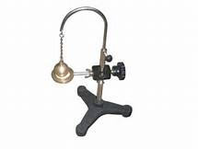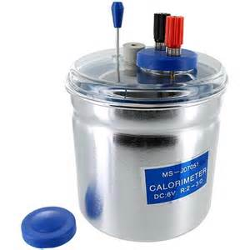

Metal linear expansion demonstrator Ball& ring apparatus with support stand Electrical calorimeter

* **Properties of matter**

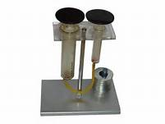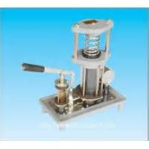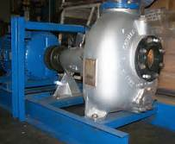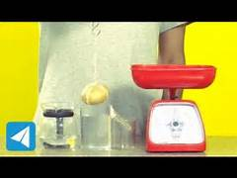

Pascal`s law apparatus hydraulic press apparatus centrifugal water pump model buoyancy theory demonstrator

* **Electricity**

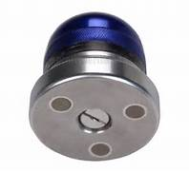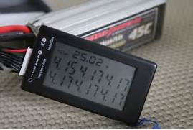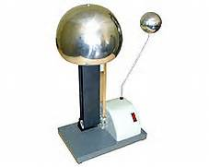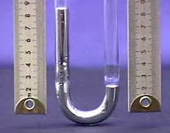

magnet photoelectric plate positive- negative charge tester Van De Graf Generator Joule`s law demonstrato

* **Magnetism**

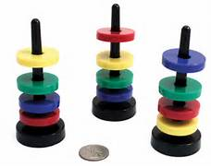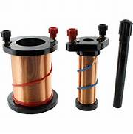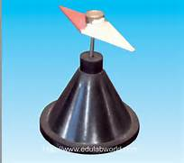

magnet ring set with stand primary-secondary coil small magnetic needle

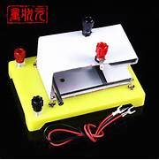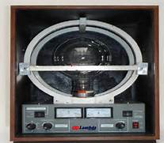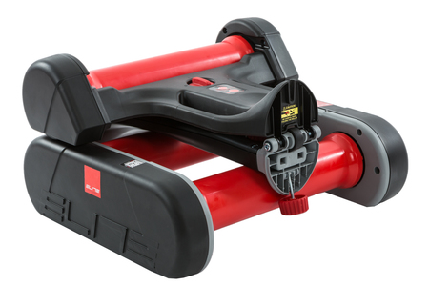

Ampere force demonstrator Lorentz force demonstrator magnet float roller

* **Light and optics**

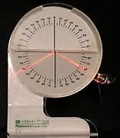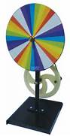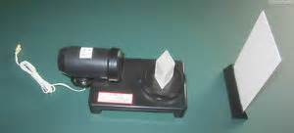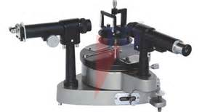

reflection and refraction tank Newton's color disc white light compo. and disper. demons. advanced spectrometer model

* **Energy**

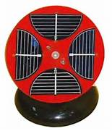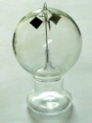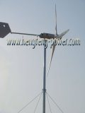

solar energy fan demonstrator Crookes Radiometer wind power generator ( Model HF 4.0- 2000W)

**Biology**

**Introduction**

Since the advancement of science across the world, practical supported biological teachings are undertaken with the aid of latest laboratory equipment to relate theoretical ideas with their practicalities.

**Tools:**

* Spoons

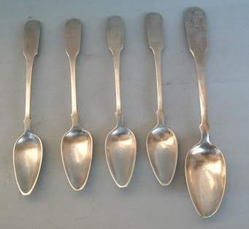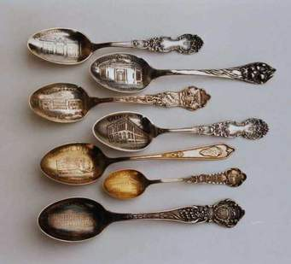

* Spatulas

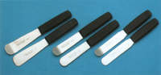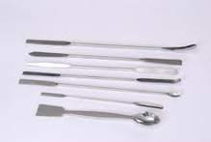

* Knives

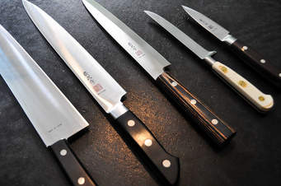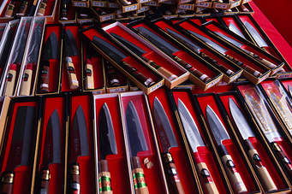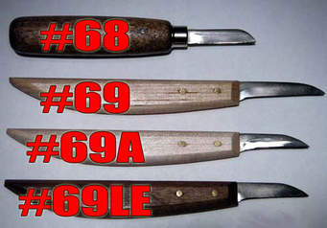

* Scissors

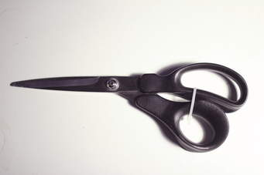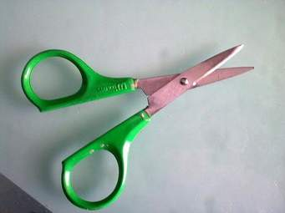

* Glass working

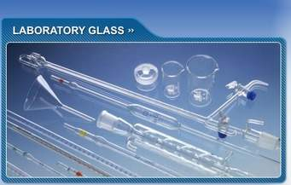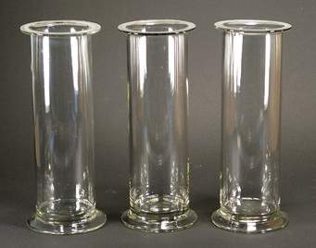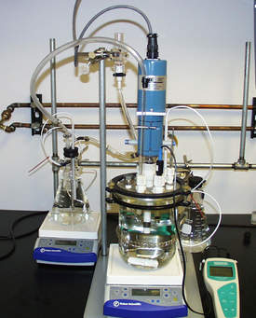

* Forceps

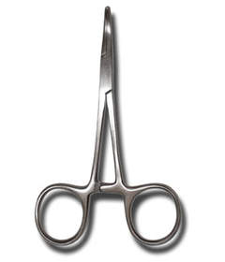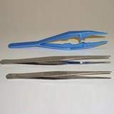

* scoops

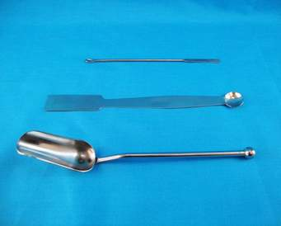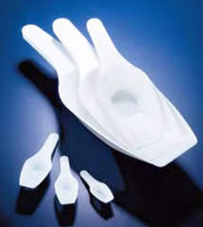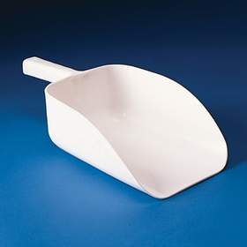

**Slides:**

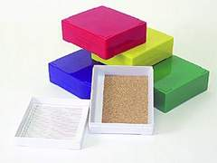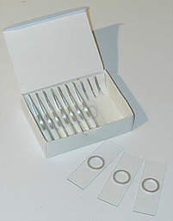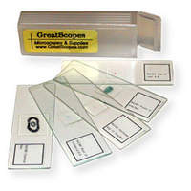

**human physiology and Anatomy**

* **Models**

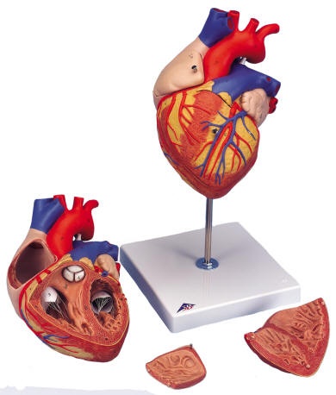

Heart model

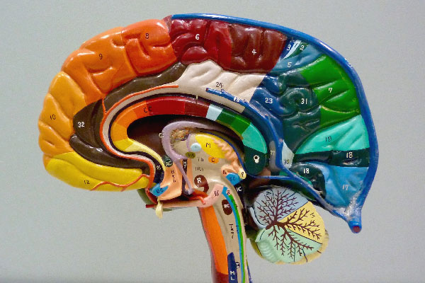

**Brain model**

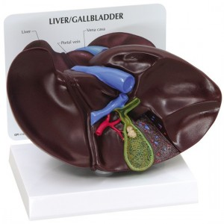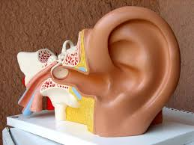

**Liver model ear model**

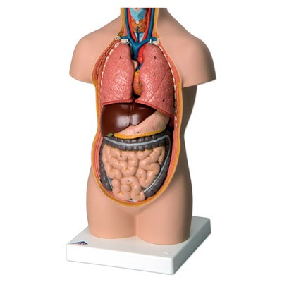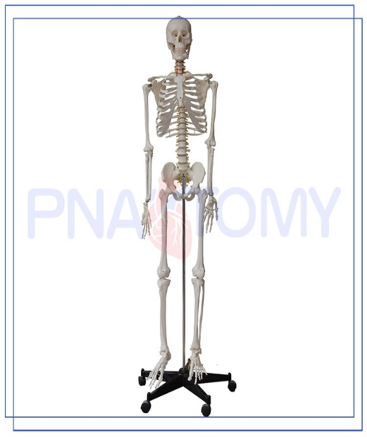

**Torso Human skeleto**

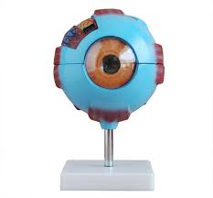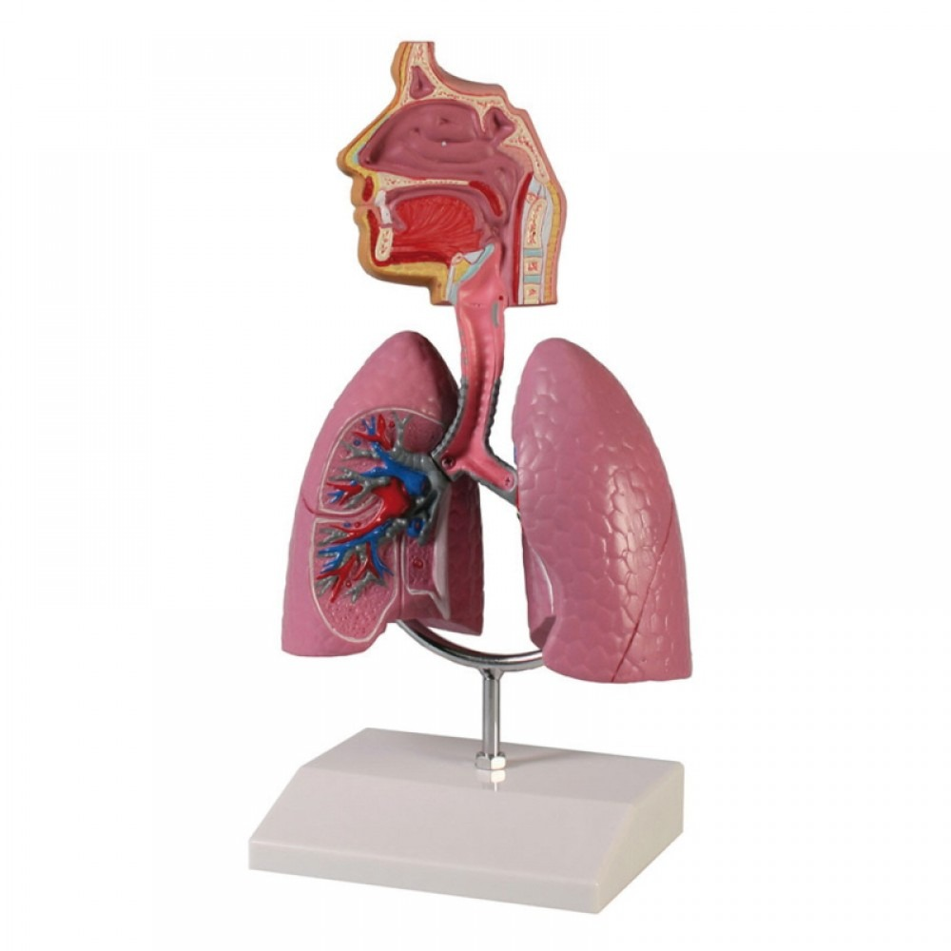

**Eye model lung model**

**Delivery model** 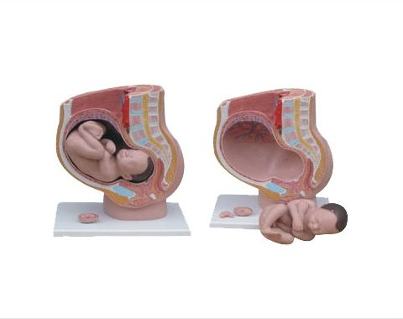

**Female pelvis and Skull models**

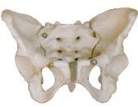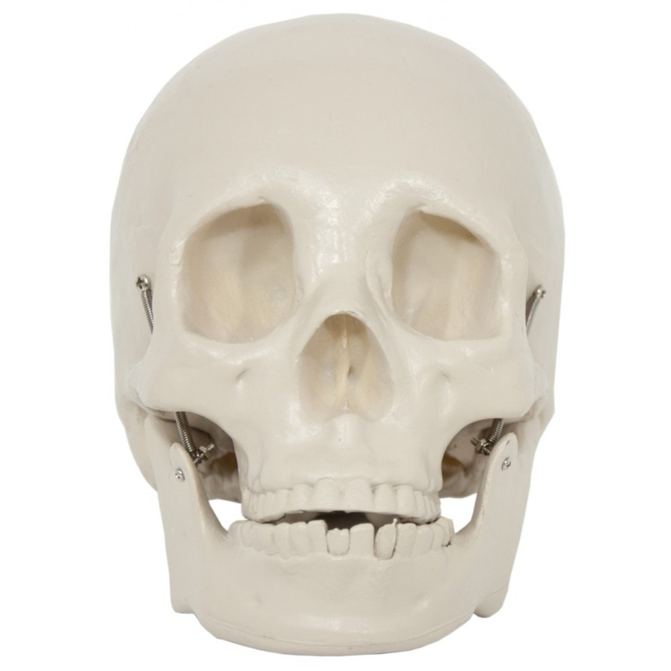

**Female pelvis model skull bone model**

**Specimens**

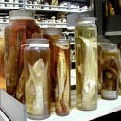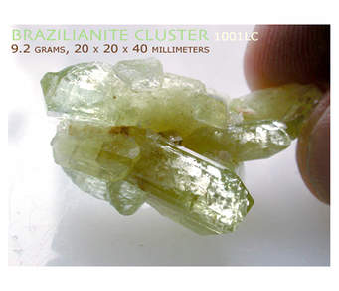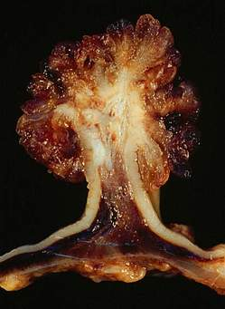

**Animal models**

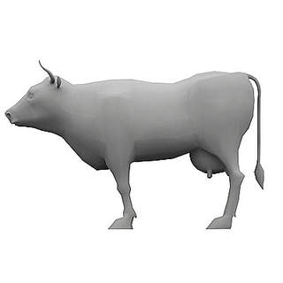

cell models

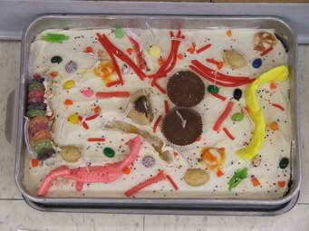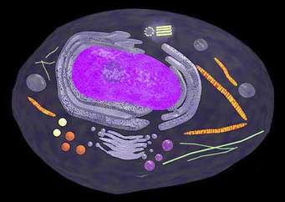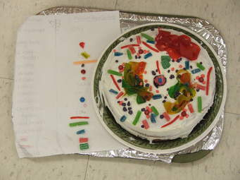

**Chemistry**

**Introduction**

Chemistry is one of the fundamental sciences being studied well through the use of technologically advanced laboratory instruments and apparatuses in the present real world. Moretech Industry PLC also support this similar undertaking to scaled up the supply and distribution of macro and micro level equipment so as to aid effective analysis of chemical reactions for chemistry learning in various levels of schools.

* **Apparatus**

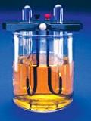 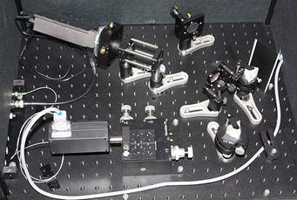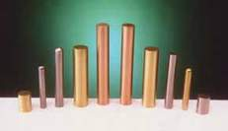

Brownlee electrolysis apparatus storage battery experiment set electrochemical experiments electrodes

* **Molecular models**

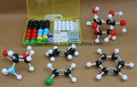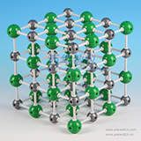

Organic molecular structure model Natural crystal Flake graphite model Ionic crystal model NaCl2

**Mathematics**

**Introduction**

Mathematical models are an important component of the final "complete model" of a system which is actually a collection of conceptual, physical, mathematical, visualization, and possibly statistical sub-models. Mathematical models can help students understand and explore the meaning of equations or functional relationships.

**Number and algebra**

* Abacus and counting frames

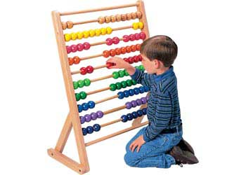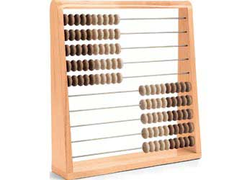

* **measurement and geometry**
* **Geometry equipment**

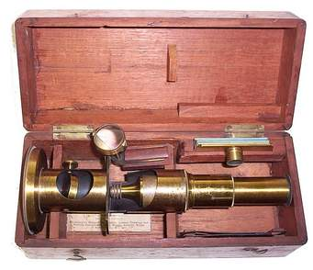 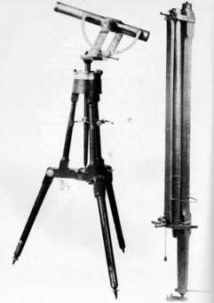 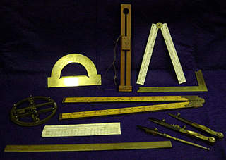

* **3D shapes and 2D shapes**

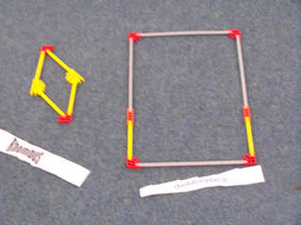

* **Volume and capacity**

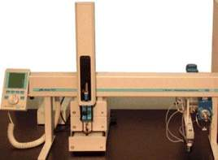 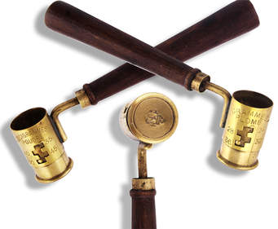

**Analytical, precision, scientific research and quality control lab equipment**

**Introduction**

Present rigorous experiments for scientific researches and findings require the highest level of analytical and precision laboratory equipment for addressing current developmental goals of the world. Researches in area of food security takes the primary icons in correspondence to others. Moretech Industry PLC in Ethiopia also handles the leading roles in the supply of such world – class precision analytical instruments to the range of institutions needing our products.

* **Environmental protection laboratory equipment**

**Soil quality analytical equipment**

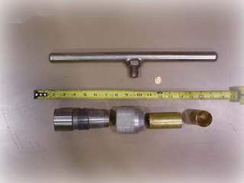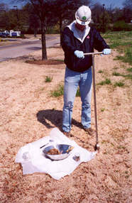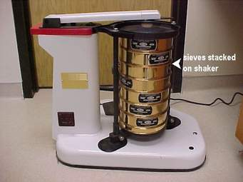

**Surface soil sampler/core cutter soil auger soil sieve set**

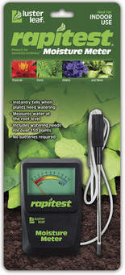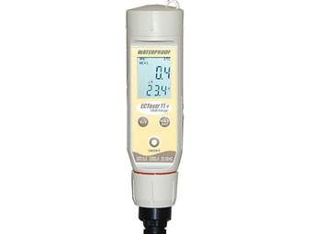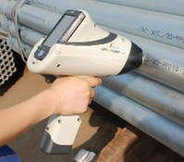

**soil moisture meter** soil conductivity/tem. meter portable XRF analyzer for screening heavy metals

**Water quality analytical equipment**

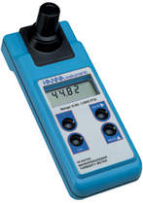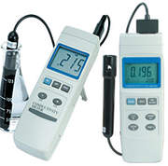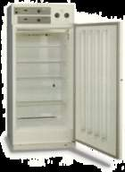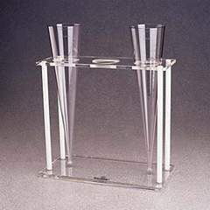

Turbidity meter conductivity meter BOD Incubators Imhoff cone standards

**Air quality analytical equipment**

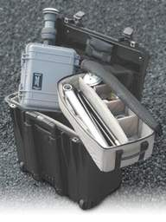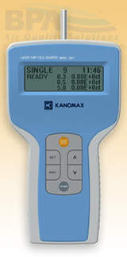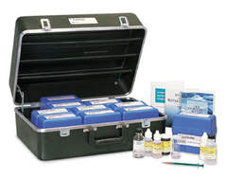

Portable ambient air sampler airborne particulate monitor air pollution test kit

* **Lab ware equipment**

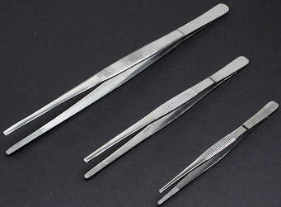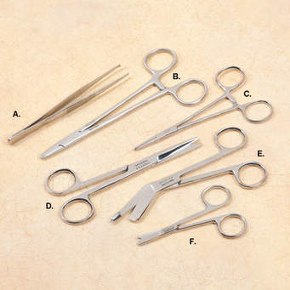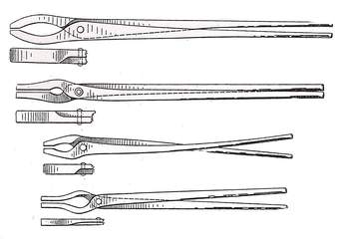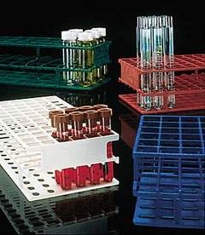

**Tweezers scissors and forceps tongs test tube racks**

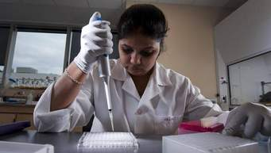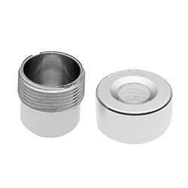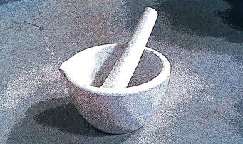

**Pipette aids crucibles mortar and pestle**

* **Glass ware equipment**

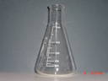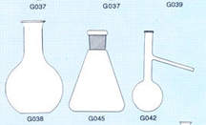

Erlenmeyer flask, narrow neck borosilicate graduated beaker long neck flat bottom conical flask wide distillation flask

Graduated Flask wide spout with side tube

* **Dish and tube**

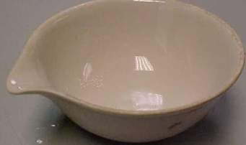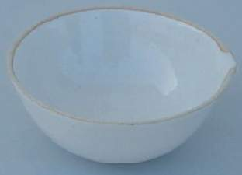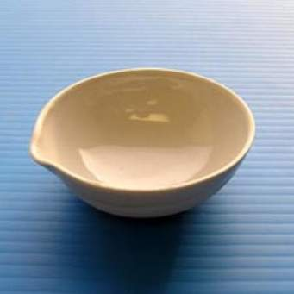

Evaporating dishes

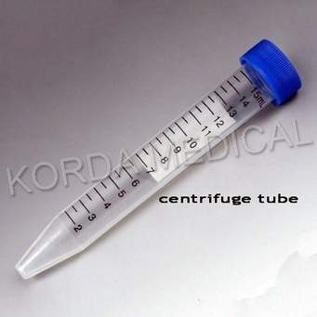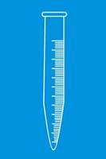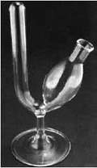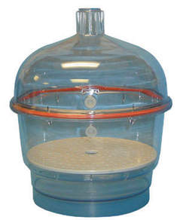

centrifuge tubes, conical fermentation tube desiccator

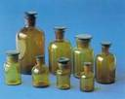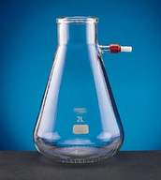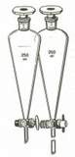

Reagent bottles with narrow mouth filter flask with upper side tube separation funnel with pear shape

Of variable size

* **Life science Equipment**

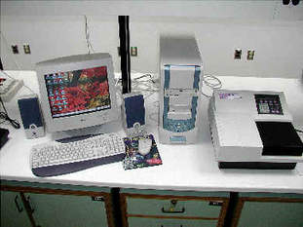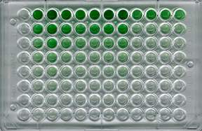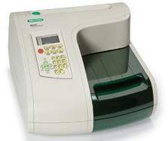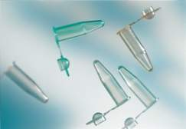

Elisa Plate serological plates microplate reader 8-stripes PCR tubes with domed caps

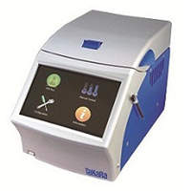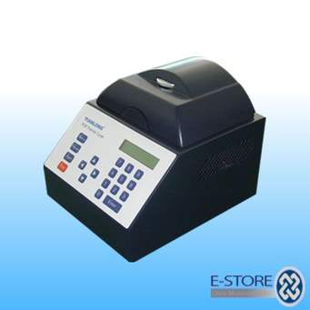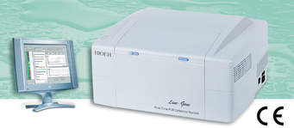

Thermal cycler DNA thermal cycler for DNA Real- time RCR detection system

Line gene I

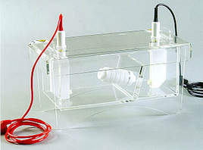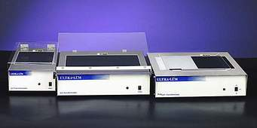

Electrophoresis: horizontal UV trans illuminator

(nucleic acid) system

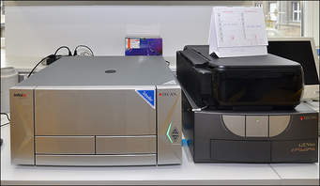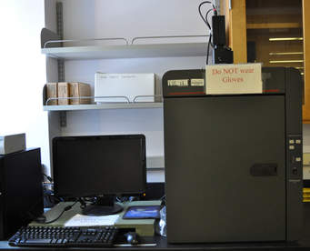

Gel documentation and imaging system

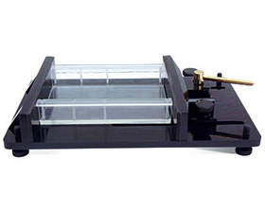

DNA electrophoresis gel generator (WD-9418)

**Genomics**

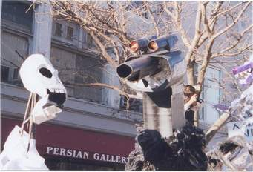 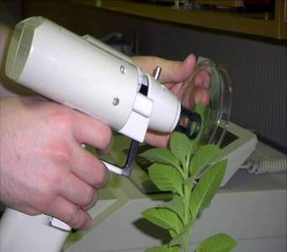 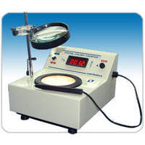

Gene gun colony counter

* **Separation and Concentration Equipment**

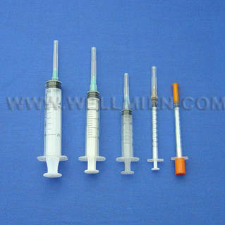 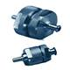 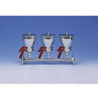

Disposable syringe filter stainless steel syringe filter holder multiple filtration apparatus

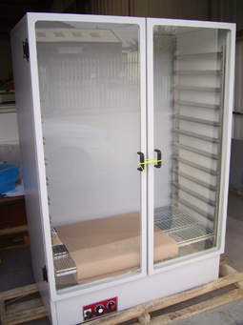 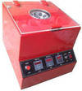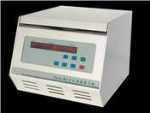

Drying cabinet for glass ware Gerber centrifuge table top high speed centrifuge

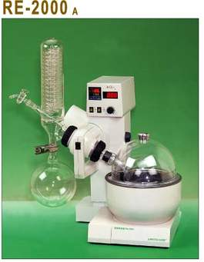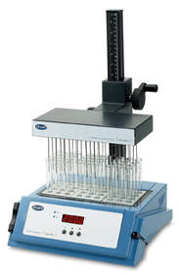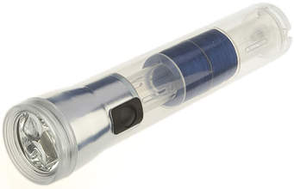

Rotary evaporator sample concentrator test sieve shaker

* **Chromatography**

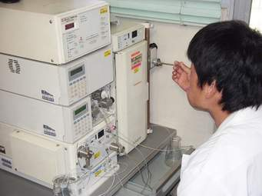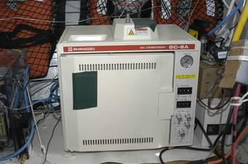

HPLC apparatus Gas chromatograph

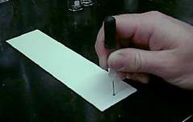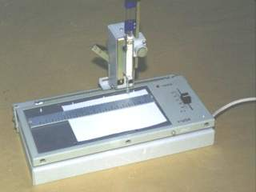

Thin layer chromatography plate Microplate reader TLC sampler

* **Laboratory equipment**

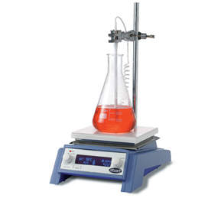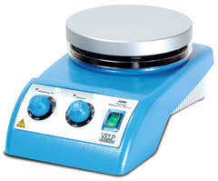 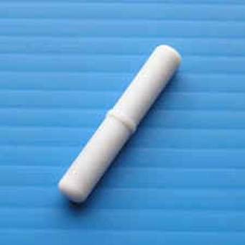

Magnetic stirrer with heating magnetic stirrer with hot plate stirring bar

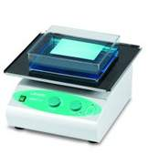 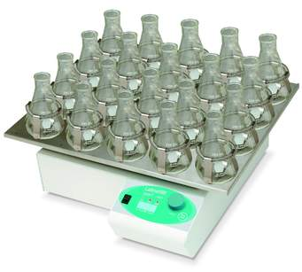 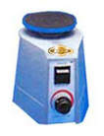

Orbital shakers vortex shaker

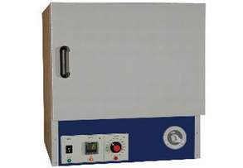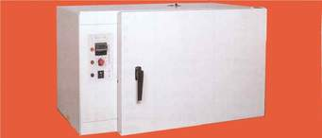

Lab Heating Incubator oven- incubator (dual purpose)

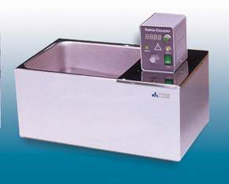 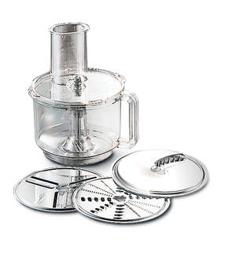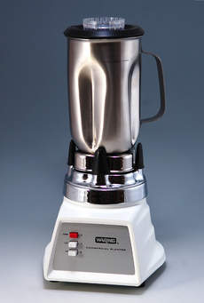

Water bath with microprocessor universal high-speed mill laboratory crushing mill

(with timing function)

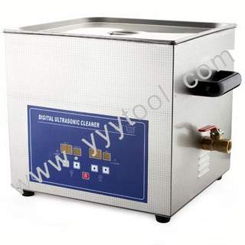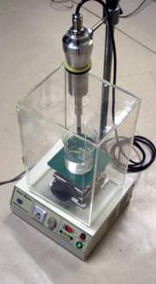

Ultrasonic cleaner homogenizer

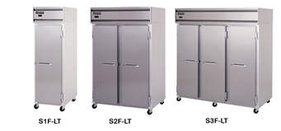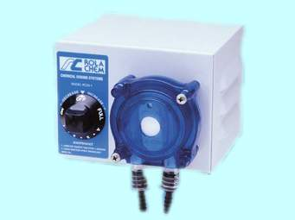

Laboratory freezers basic type peristaltic pump

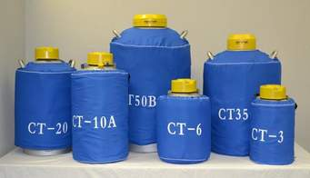

Liquid nitrogen tank for storage

* **analytical equipment**

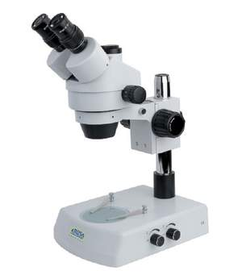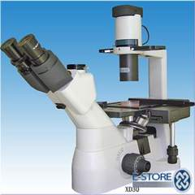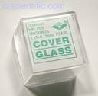

Stereo microscope inverted biological microscope cover glass

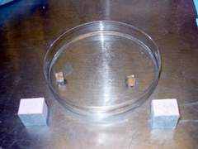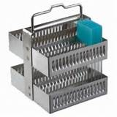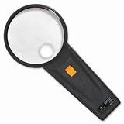

Microscope slides staining dishes staining racks illuminated magnifier

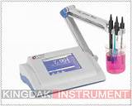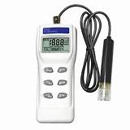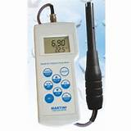

Bench top meter conductivity data dissolved oxygen meter

Single -parameter logging meter

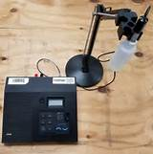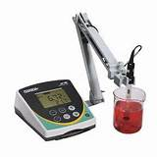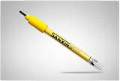 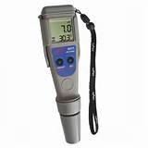

Ion analyzer PH conductivity meter/bench top conductivity electrode Pocket PH tester

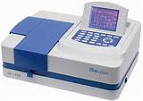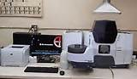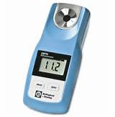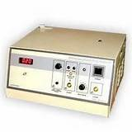

UV/Vis spectrophotometer atomic absorption flames digital refractometer digital melting

spectrophotometer point apparatus

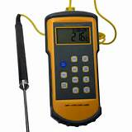

Digital thermometer

* **Work ware and safety**

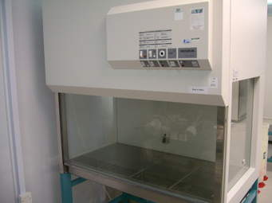 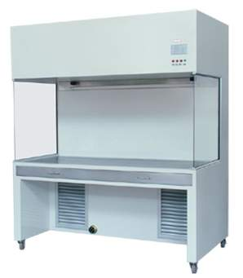

Biological safety cabinet II clean bench

**Laboratory Chemicals Product Range: (reagents, culture media/tissues culture, biological substances such as; hormones, enzymes, agars, etc)**

**Introduction**

Range of laboratory chemicals such as; plant tissue culture, molecular biology, animal cell culture, Expert teaching aids, laboratory aids and equipment, microbiology and others have been getting significant acceptance in the 21th  century because of the advancement of biotechnological researches. Observing the real situation of the wide gaps present in our country and the correspondence increment of their demand; our company is working much on importation and supply of laboratory chemicals, reagents, tissue cultures, culture medias and others profoundly.

* **Ready prepared media:**
* Prepared media plates

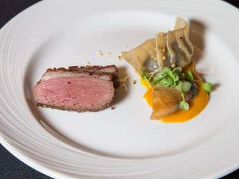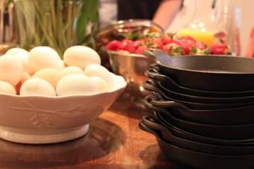+

* biochemical test kits for mycobacteria

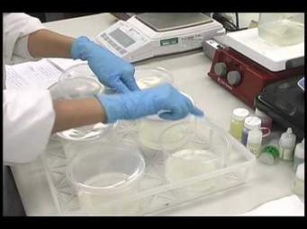

* **Dehydrated culture media bases and supplements:**
* animal protein based culture media

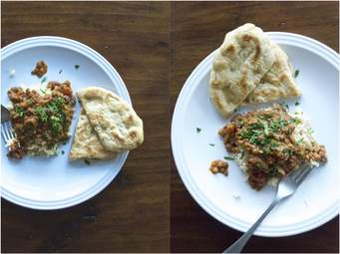 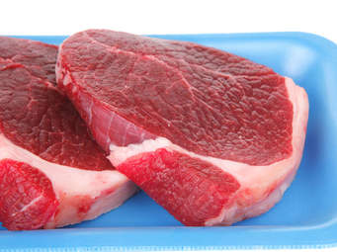

* vegetable protein based media (HiVeg media)

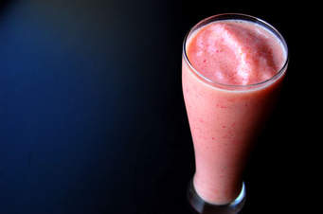 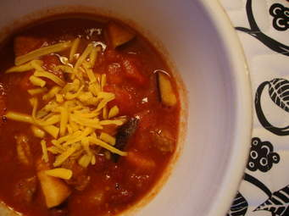 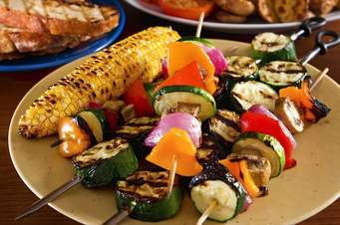

* antibiotic assay media

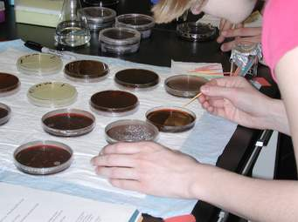 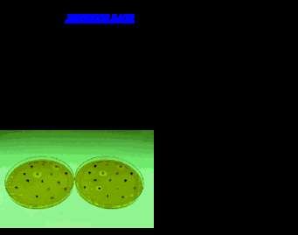

* Media supplements

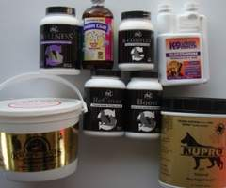  

* Antimicrobial susceptibility systems
* Antibacterial

 

* Bacteriological differentiation aids
* Discs for carbohydrate fermentation test

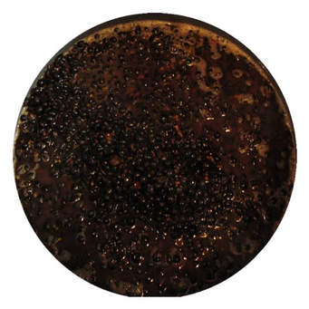 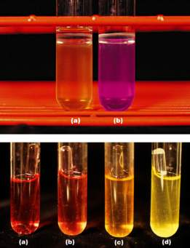 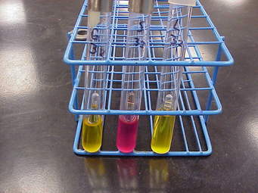

* Cell culture media
* Staining kits for cytology

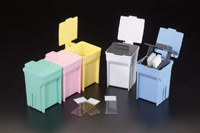 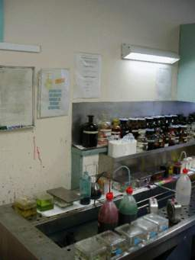 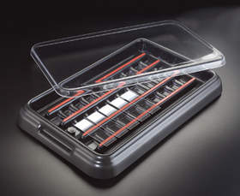

* Readymade indicators

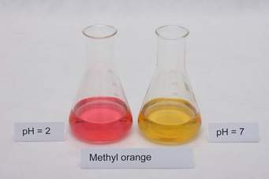 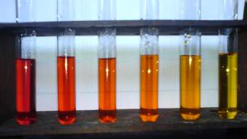

* Readymade strains for bacteria and bovine cells in milk

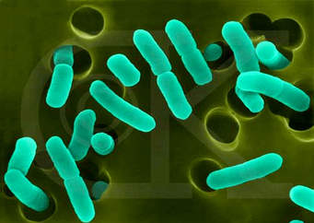 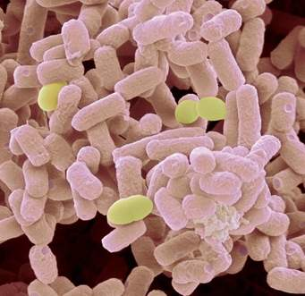 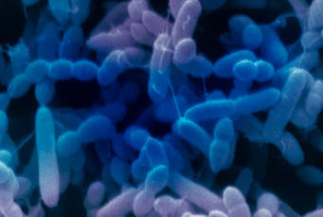

* **Plant tissue culture**
* phycology media (liquid sterile filtered)

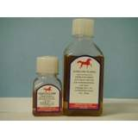 http://media4.picsearch.com/is?oSGzvI0YYJ8acuJ0HSTNQijdf5Z_bs5mDoAbTmvDPco&height=55 http://media2.picsearch.com/is?T3dqsGYz5BjnvYZcoAzzhRolsDfqyhSVoOwfskYZ2Fw&height=55

* **Molecular biology kits, chemicals, reagents & growth**
* Density gradient separation media

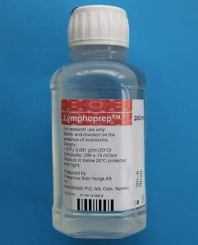

* **Laboratory aids**
* Sterile disposable petri plates

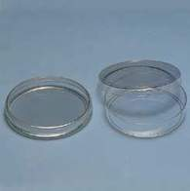 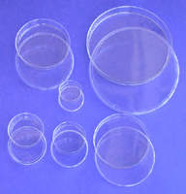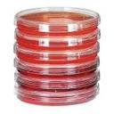

* PCR tubes and plates

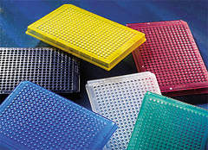

**Modern agricultural equipment and machineries**

**Introduction**

More specialized agricultural machineries, dairy and beekeeping instruments and laboratory equipment have been supplied to several medium to higher level governmental and non- governmental organizations since 1999. Some of our major products in this area are; milk processing and milking machines, lactoscan, poultry feeder and drinker, brooder, hatching incubator, debeaker, butyrometer and milk refractometer. At present; Moretech Industry PLC is well equipped in management,finance and supportive staffs and technical experts such as electrical and chemical engineers, biotechnologists, agriculturalists, veterinarians and environmentalists with their time- tested experience over the ranges of the instruments.

* **Beekeeping (apiculture) instruments**

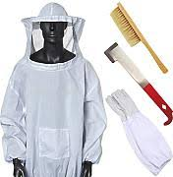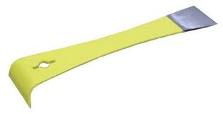

Bee veil Chisel

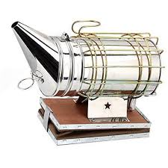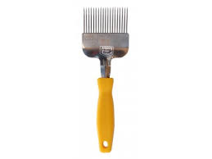

Smoker uncapping fork

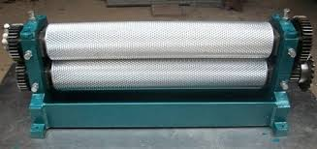

Wax printer bees wax

* **Poultry production equipment**

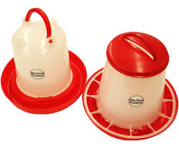

* Poultry feeder and drinker

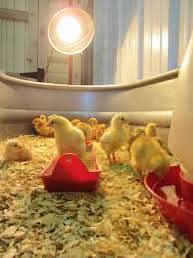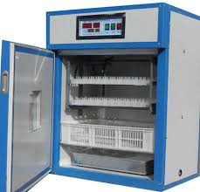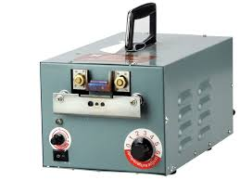

Brooder Hatching Incubator Debeaker

* **Dairy production equipment and Milk analyzing equipment**

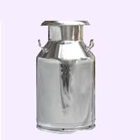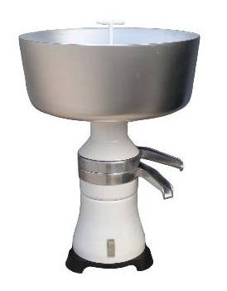

Milk collecting can Cream separator

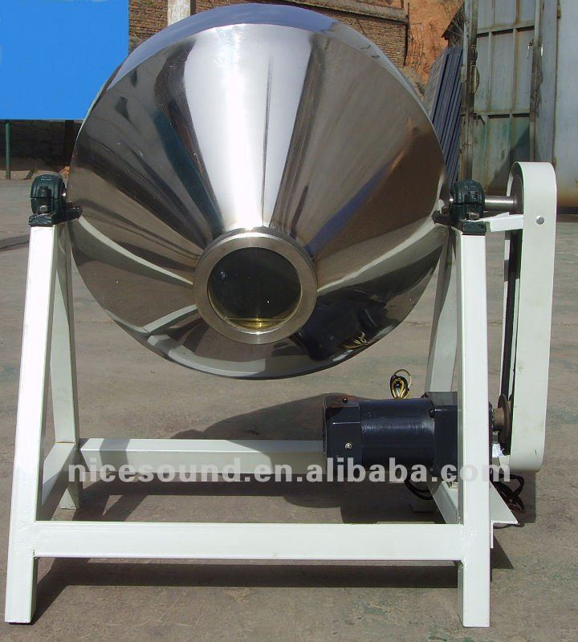

Milk churner

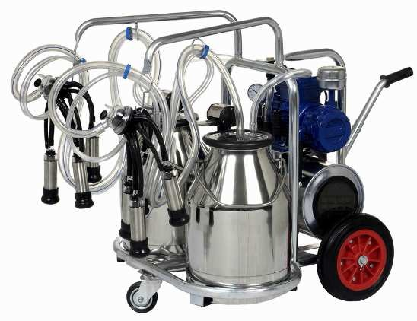

Milking machine

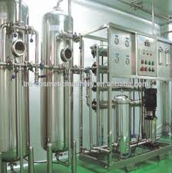

Milk Processing machine

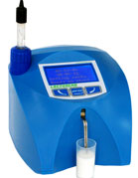 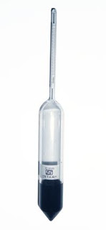

Lactoscan lactometer

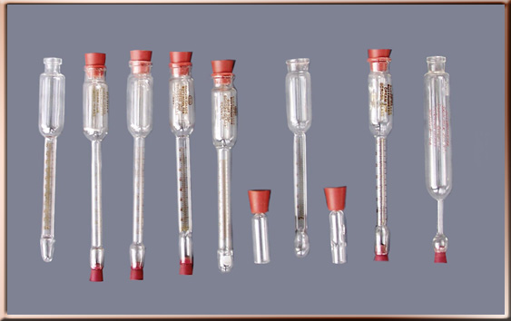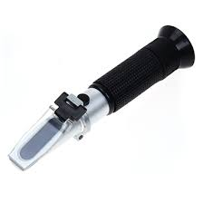

Butyrometer Milk refractometer

**Equipment for teaching engineering and vocational training institute**

**Introduction**

Advance learning at universities particularly in area of engineering requires very latest instrumentations to equip scholars and feed with technical skills that alleviate the current problem of industrial advancement. Similar occasion in Ethiopia is observed and this creates vital opportunities for companies such as; Moretech Industry PLC to engage in the sector for importation and supply of high quality laboratory and workshop equipment to those higher academic institutions and related enterprises so as to narrow the scope scarcity.

* **Electrical engineering equipment**

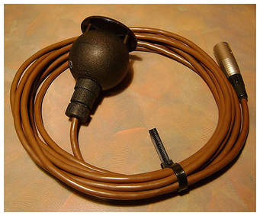 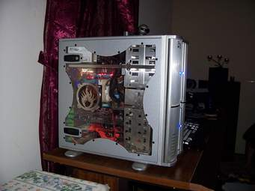 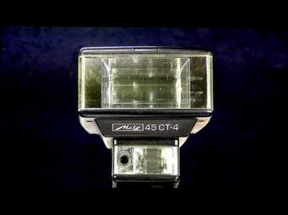

Petersen coil VT load CT load

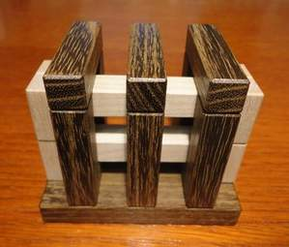 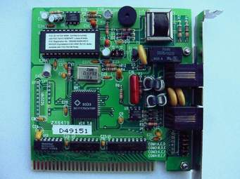 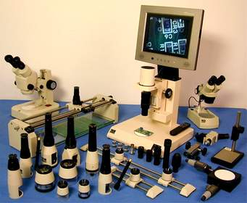

Three level frames phase circuits resistor module for measuring the input

* **Mechanical engineering**

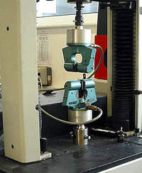 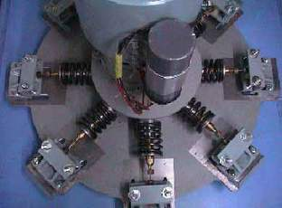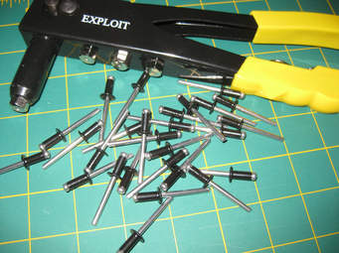

Fatigue testing spacemen torsion testing spacemen rivet gun

 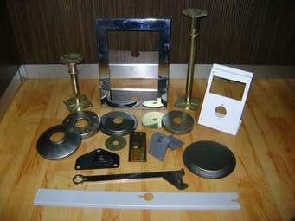 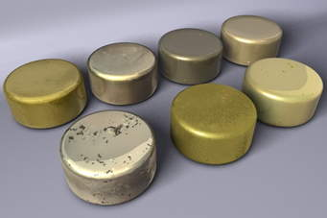

Machine brush sheet metal divider metal steko

* **Chemical engineering equipment**

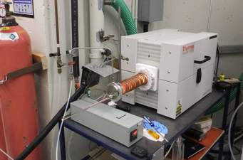 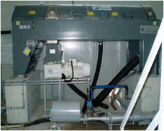

Laboratory furnace decanter centrifuge

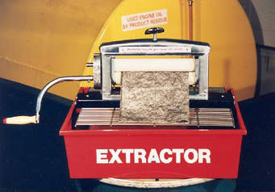 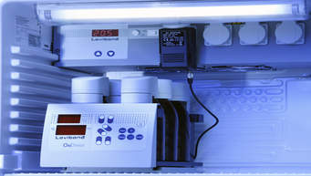

Benchtop rapid extractor BOD tester

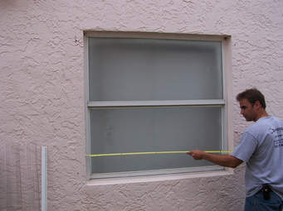 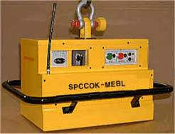 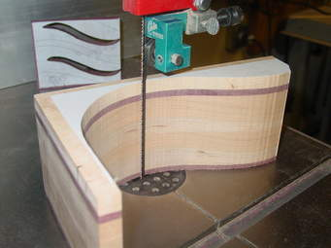

Measuring bearer magnetic agitator stabilizer

**Aluminum door and widow works**